PROJECT REPORT ON

“BIOMETRIC TICKET GATE”

Biometric attendance management system

BY

WAQAS-UR-REHMAN

ZAIN-UL-HASSAN

TAIMOOR TANVEER

MUHAMMAD AJMAL

Supervised by

ALI SYED

JANUARY 2015

CENTER FOR ADVANCED STUDIES IN ENGINEERING

19- ATTATURK AVENUE

G5 / 1 ISLAMABAD, 44000 PAKISTAN

BIOMETRIC TICKET GATE PROJECT

AMN SCHOOL F-10 ISLAMABAD

INTRODUCTION

This was a project of a Biometric ticket gate of school name (AMN International School) at F-10 Islamabad. Project we program a biometric thumb impression for security purpose.

PROGRAM SOFTWARE

The programming software is “iSecure RFID”.

Program work in following

1. Security updates
2. Real time attendance management
3. Thumb impression record
4. Daily synchronization
5. Daily datasheet update

HARDWARE WORK

1. Mechanical work
2. Wiring of hardware
3. Connection with the software

CIRCUIT DETAIL

Biometric RFID Device

Power supply of 18v-18v/4amp

Distribution and Connections

BLOCK DIAGRAM

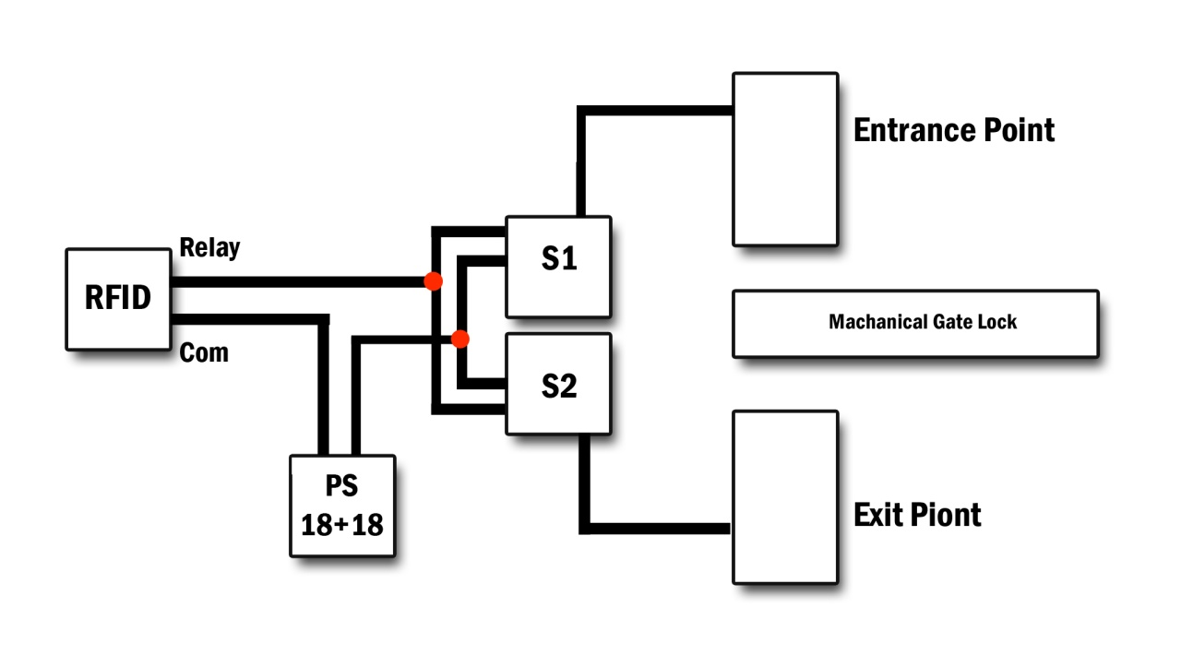

EXPLANATION OF BLOCK DIAGRAM

SUMMARY

The Biometric machine is connected to the S1 & S2 (Coils with Plungers) and power supply, trough Relay, Com and Gnd. S1 & S2 are connected with the entrance and exit points, and center mechanically lock.

PROCEDURE

1. Hardware & software actives through powers.
2. Device gets the thumb impression.
3. Its signals on the hardware coils (S1 & S2).
4. Record real time attendance in software.
5. Coils active the S1 & S2, it should be open.
6. The moveable mechanical lock moves and closes after given time in seconds.